Plight of the Bumblebee: A look at interspecific competition between two species of *Nosema* and their interactions with RNA viruses

**INTRODUCTION:**

The documented decline of important pollinators has garnered much attention and concern in recent years. Bumblebees (*Bombus spp.*) in particular are important native pollinators whose decline has been understudied in light of managed honeybee (HB) losses. Certain plants, most notably of the genus *Solanum* (tomatoes, potatoes and eggplant), primarily rely on pollination provided by bumblebees and honeybees are poor pollinators of these plants (Buchmann and Hurley, 1978, Strange, 2015; Thornsbury and Jerardo, 2012). Bumblebee declines in recent years have the potential to drastically disrupt the pollination services they provide and the industries that rely on them. Species such as *B. affinis, B. borealis, B. ashtoni, B. fervidus, B. pensylvanicus, and B. sandersoni* (all species that can be found in Vermont) have decreased in abundance since the 1960s (Colla et al., 2012). In 2015, the state of Vermont listed two species of *Bombus* as threatened (*B. terricola and B. ashtoni*) and one as endangered (*B. affinis*) (Vermont Fish and Wildlife Department, 2015).

There are a number of pathogens that are thought to be causing bumblebee declines including the microsporidian parasite *Nosema spp*. as well as a number of RNA viruses. *Nosema* lives in the ventriculus of its host, and has been shown to cause dysentery and adversely affect behavior by decreasing forging efficiency (Otterstatter et al., 2005).There are two species of *Nosema* that affect bumblebees, *N. bombi* (the native species) and an invasive species (*N. ceranae*). *N. ceranae* hasbecome ubiquitous in the European honeybee (*A. mellifera*), and outcompetes *A. mellifera’s* unique species of *Nosema*, *N. apis* (A. Bourgeois et al., 2010; M. Natsopoulou et al., 2014). In addition to *Nosema*, RNA viruses original discovered in honeybees have been found in bumblebee populations (M.A. Fürst et al., 2014). RNA viruses like Deformed Wing Virus (DWV) and Black Queen Cell Virus (BQCV) cause behavior abnormalities, inefficient foraging, wing deformities and death (D. Schroeder and S. Martin, 2012; P. Graystock et al., 2015).

Although *Nosema* and RNA pathogens have been documented in bumblebees, interactions between these pathogens and their host have been understudied. I will examine if the introduction of the invasive parasite *N. ceranae*has led to interspecific competition with *N. bombi*. In addition, I will examine if coinfection between *Nosema spp.* and RNA viruses (DWV and BQCV) leads to synergistic effects that further compromise bee health. **(I)** I predict that *N. ceranae* will outcompete *N. bombi* when both parasites coinfect the host. **(II)** I also predict that the presence of *Nosema spp.* will depress the bees' immune system, resulting in levels of viral infection than when *Nosema* is not present.

**METHODS:**

***What has been done:*** In 2014, 357 *Bombus* specimens were collected haphazardly from 13 different sites in Northern Vermont. The bees netted while foraging on flowers without regard to species.. The bees were put on dry ice in the field and were transferred to a -80oC freezer within 12 hours of being captured. In 2015-2016, specimens were assayed for *Nosema spp.* (*both N. ceranae and N. bombi*) by dissection. . *Nosema* counts were made for each bee using a hemocytometer. The presence of viruses was assayed using standard, molecular (PCR) techniques.

***What will be done during summer 2016:*  (I)** To look at interactions between *Nosema* and RNA viruses, a sub ample (N=40) of the 2014 survey bees from both the *Nosema* positive and *Nosema* negative specimens will be assayed for two RNA viruses (DWV and BQCV) and a housekeeping gene (ACTIN) using RT-qPCR. Parasite load will be analyzed as a predictor of viral load**. (II)** To look at interspecific competition between *N. ceranae* and *N. bombi*, a controlled lab experiment (using commercial Koppert® bumblebees) consisting of 4 treatments (2 by 2 factorial study, N=30) will be conducted. *Nosema spp.* will be isolated and cultured using standard methods (I. Fries et al., 2013). The Koppert® bees will be subsampled and assayed for *Nosema* prior to the experiment to ensure no initial infection. Bees will be inoculated orally and kept in a growth chamber. After 2 weeks *Nosema* loads will be determined using RT-qPCR. The data from both experiments will be analyzed and the interactions modeled using statistical packages in R (an open-source, online statistical analysis program).

***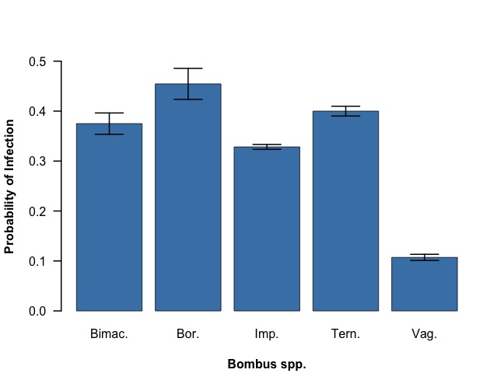*RESULTS:**

***Preliminary data from 2015-2016:***

The *Nosema* count data collected from the 2014 bumblebee survey demonstrated that the parasite is very common, and the probabilities of infection vary among bumblebee species (Fig 1). Caste (Queen/worker/male) had no bearing on probability of infection. The parasite appeared to be prevalent on the landscape with a mean probability of 0.333, which increases the chances of coinfection with other pathogens such as DWV or BQCV.

*

**Fig. 1.** The probability of infection for five common *Bombus* *spp*.: *bimaculatus* (Bimac.), *borrealis* (Bor.), *impatiens* (Imp.), *ternarius* (Tern.) and *vagans* (Vag.). *B. vagans* was found to have a lower prob. of infection (0.107). The mean prob. of infection for all species was 0.333.

***Expected findings & Future plans:*** Research into the health of both managed and wild pollinators is a lifelong passion of mine. I have kept honeybees since the age of 12 and have become very invested in understanding the forces that are contributing to their demise. The work I propose here will provide the foundation for my accelerated Master's project which I will complete in 2018.